Bonfring Publication | 

Thesis Publication Guidelines

Dear Author(s),

We suggest the authors to structure their thesis based on the following instructions. This would help in the effective and smooth transformation of your thesis into the final publication version.

Contents to be included in the Thesis

Title page | Title (and subtitle) final
Authors/Editors | All author/editor names included  e-mail address of corresponding author included
Front matter | Complete with the following elements:  - Dedication  - Foreword  - Preface o Acknowledgments  - Table of contents (required)  - List of contributors  - List of abbreviations
Table of contents | - Monographs: first 2 levels of headings appearing in chapters are included  - Contributed thesis: chapter titles and author names included  - Headings correspond to those in the text
Thesis structure | Number of parts  Number of chapters  All chapters numbered sequentially throughout the thesis (or not numbered at all)  Chapter sequence and numbering final
Abstract | Included for each chapter
Text | Heading levels and special text elements consistently styled  No heading levels skipped
References | Reference list included at the end of each chapter  Citations in text agree with reference list  Reference list style according to Springer’s guidelines
Figures | All figures mentioned in text enclosed, complete, and as separate files  Consecutively numbered within chapter  Consecutively cited in text
Tables | Prepared with the table function  Consecutively numbered within chapter  Consecutively cited in text
Electronic thesis | File folder/zip archive labeled with thesis title and author/editor name  Each chapter saved as a separate file in the original file format
Contributed thesis | - Email addresses and affiliation included for at least the corresponding author of each chapter  - Consent to publish for each chapter
Permissions | - Included for all material from other works

Thesis Preparation Guidelines

Page Layout
Your paper must use a page size corresponding to “Letter” which is (8.5") wide and (11") height. The margins must be set as follows:
- Top = Bottom = (0.7")
- Left = Right = (0.65")

Level 1- Heading
Heading 1 is applicable for the session heading such as (chapters name). First word heading1 should be caption and rest should be small caption.
- Before spacing=12 pt
- After spacing=4 pt

Level 2- Heading
Heading 2 is applicable for sub-headings which are coming under the Heading 1 and it should be in italic style. Rather than sub-heading the users are allowed to use the numbering points and bulleted list in the consecutive list of heading 1, heading 2. Before spacing and after spacing of figure caption and table caption are same.
- Before spacing=6 pt
- After spacing=3 pt

Level 1- Heading
No more than 3 levels of headings should be used.

Level 2- Heading
- Subheading1
- Point1
- Subheading2
- Points1
- Points2

Table 1: Font Sizes for Papers
Font Size | Appearance (in Time New Roman or Times)
Font Size | Regular | Bold | Italic
10 | Abstract/keywords/heading1/ heading2/all paragraph/bulleted points/ table caption/figure caption/ Chart title/Chart specifications | Abstract/keywords | Abstract/keyword/abstract content/keyword content/content highlight
9 | Table content | - | Table content highlights
24 | Chapter 1 (Main Heading)

Figures and Tables
Figures and tables must be centered. Avoid screen shot and snap shot for tabulation and figures, if so, all figures should be visible and should not be blurred. Tabulation should be editable.

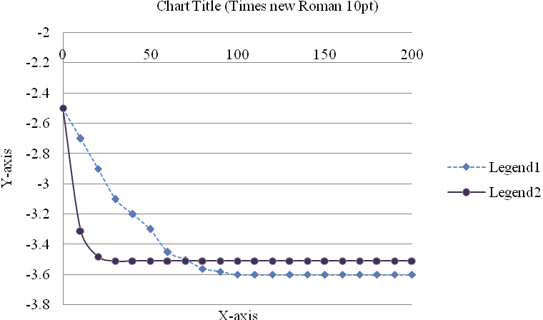
Figure 1: Comparison Legend1 and Legend2

Figure Captions
Figures must be numbered using Arabic numerals. Figure captions must be in 10 pt regular font as mentioned in Table 1. Captions for figures must be centered. Every word in a Figure caption must be capitalized except for preposition words such as “a”, “an”, “and”, “as”, “at”, “by”, “for”, “from”, “if”, “in”, “into”, “on”, “or”, “of”, “the”, “to”, “with”, etc. Figure caption should not end with full stop.
- Before spacing=6 pt
- After spacing=3 pt

Table Captions
Tables must be numbered using Arabic numerals. Table captions must be centred and in 10 pt regular font. Every word in a table caption must be capitalized except for short minor words as shown in table 1 caption. Captions with table numbers must be placed before their associated tables, as shown in Table 1. Every word in a table caption must be capitalized except for preposition words such as “a”, “an”, “and”, “as”, “at”, “by”, “for”, “from”, “if”, “in”, “into”, “on”, “or”, “of”, “the”, “to”, “with”, etc. Table caption should not end with full stop.
- Before spacing=6 pt
- After spacing=3 pt

Important Note

Math
If you are using Word, use either the Microsoft Equation Editor or the MathType add-on (http://www.mathtype.com) for equations in your paper (Insert | Object | Create New | Microsoft Equation or MathType Equation). “Float over text” should not be selected.

Units
Use either SI (MKS) or CGS as primary units. (SI units are strongly encouraged.) English units may be used as secondary units (in parentheses). This applies to papers in data storage. For example, write “15 Gb/cm² (100 Gb/in²).” An exception is when English units are used as identifiers in trade, such as “3½ in disk drive.” Avoid combining SI and CGS units, such as current in amperes and magnetic field in oersteds. This often leads to confusion because equations do not balance dimensionally. If you must use mixed units, clearly state the units for each quantity in an equation.
The SI unit for magnetic field strength H is A/m. However, if you wish to use units of T, either refer to magnetic flux density B or magnetic field strength symbolized as µ₀H. Use the center dot to separate compound units, e.g., “A·m².”

References
Number citations should be consecutively in square brackets [1]. The sentence punctuation follows the brackets [2]. Multiple references [2], [3] are each numbered with separate brackets. When citing a section in a thesis, please give the relevant page numbers [2]. In sentences, refer simply to the reference number, as in [3]. Do not use “Ref. [3]” or “reference [3]” except at the beginning of a sentence: “Reference [3] shows ....” Unfortunately the World Bonfring Society document translator cannot handle automatic endnotes in Word; therefore, type the reference list at the end of the paper using the “References” style. 15 to 25 references should be there.

Table 2: This Table is in not Compatible for Double Column Format
X | 100 | 200 | 300 | 400 | 500 | 600 | 700 | 800 | 900 | 1000
A(e) | 198 | 395 | 588 | 790 | 971 | 1174 | 1357 | 1569 | 1759 | 1941
 | 1.980 | 1.975 | 1.960 | 1.975 | 1.942 | 1.957 | 1.939 | 1.961 | 1.954 | 1.941
µ | 103 | 276 | 364 | 927 | 728 | 901 | 544 | 362 | 1987 | 1567

Equations
Number equations consecutively with equation numbers in parentheses flush with the right margin, as in (1). First use the equation editor to create the equation. Then select the “Equation” markup style. Press the tab key and write the equation number in parentheses. To make your equations more compact, you may use the solidus (/), the exp function, or appropriate exponents. Use parentheses to avoid ambiguities in denominators. Equation should be visible and editable. Punctuate equations when they are part of a sentence, as in
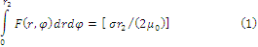
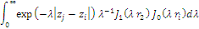

Be sure that the symbols in your equation have been defined before the equation appears or immediately following. Italicize symbols (r might refer to temperature, but is the unit tesla). Refer to “(1),” not “Eq. (1)” or “equation (1),” except at the beginning of a sentence: “Equation (1) is ....”

Abbreviations and Acronyms
Define abbreviations and acronyms the first time they are used in the text, even after they have already been defined in the abstract. Abbreviations such as IES, SI, ac, and dc do not have to be defined. Abbreviations that incorporate periods should not have spaces: write “C.N.R.S.,” not “C. N. R. S.” Do not use abbreviations in the title unless they are unavoidable (for example, “World Bonfring Society” in the title of this article).

Some Common Mistakes
The word “data” is plural, not singular. The subscript for the permeability of vacuum µ₀ is zero, not a lowercase letter “o.” The term for residual magnetization is “remanence”; the adjective is “remanent”; do not write “remnance” or “remnant.” Use the word “micrometer” instead of “micron.” A graph within a graph is an “inset,” not an “insert.” The word “alternatively” is preferred to the word “alternately” (unless you really mean something that alternates). Use the word “whereas” instead of “while” (unless you are referring to simultaneous events). Do not use the word “essentially” to mean “approximately” or “effectively.” Do not use the word “issue” as a euphemism for “problem.” When compositions are not specified, separate chemical symbols by en-dashes; for example, “NiMn” indicates the intermetallic compound Ni_{0.5}Mn_{0.5} whereas “Ni–Mn” indicates an alloy of some composition Ni_{x}Mn_{1-x}.
Be aware of the different meanings of the homophones “affect” (usually a verb) and “effect” (usually a noun), “complement” and “compliment,” “discreet” and “discrete,” “principal” (e.g., “principal investigator”) and “principle” (e.g., “principle of measurement”). Do not confuse “imply” and “infer.”
Prefixes such as “non,” “sub,” “micro,” “multi,” and “"ultra” are not independent words; they should be joined to the words they modify, usually without a hyphen. There is no period after the “et” in the Latin abbreviation “et al.” (it is also italicized). The abbreviation “i.e.,” means “that is,” and the abbreviation “e.g.,” means “for example” (these abbreviations are not italicized).

Appendix
Appendixes, if needed, appear before the acknowledgment. Appendix and acknowledgment is optional. First word should be caption and rest should be small caption. No specification of numbering.

Acknowledgment
The preferred spelling of the word “acknowledgment” in American English is without an “e” after the “g.” Use the singular heading even if you have many acknowledgments. Avoid expressions such as “One of us (S.B.A.) would like to thank ....” Instead, write “F. A. Author thanks ….”

References
- Initial of author, name, “Title of Reference Paper”, Publication Name, Vol no, Issue no, page no, year of publication.
- K.M. KenchiReddy and C.T. Jayadeva, “The Effects of Welding Processes on Microstructure and Abrasive Wear Resistance for Hardfacing Deposits”, Bonfring International Journal of Industrial Engineering and Management Science, Vol. 2, No.2, Pp. 28-34, 2012.
- V. Venkatesa Kumar and K. Dinesh, “Job Scheduling Using Fuzzy Neural Network Algorithm in Cloud Environment’, Bonfring International Journal of Man Machine Interface, Vol. 2, No. 1, Pp. 01-06, 2012.

After preparing the thesis in the mentioned format, submit to info@bonfring.org

For more information, contact,
Bonfring Corporate Office,
Publication Division,
309, 5th Street Extension, Gandhipuram,
Coimbatore – 64102, India.
Phone: (+91) 8220878604

